

FOR IMMEDIATE RELEASE:
April 23, 2025

JOSHUA REDMAN ANNOUNCES JUNE 20 RELEASE OF
HIS SECOND BLUE NOTE ALBUM WORDS FALL SHORT
AN INTRODUCTION OF HIS NEW QUARTET FEATURING
PAUL CORNISH, PHILIP NORRIS & NAZIR EBO
PLUS SPECIAL GUEST APPEARANCES BY
GABRIELLE CAVASSA, MELISSA ALDANA & SKYLAR TANG

LISTEN TO THE LEAD SINGLE “A MESSAGE TO UNSEND”

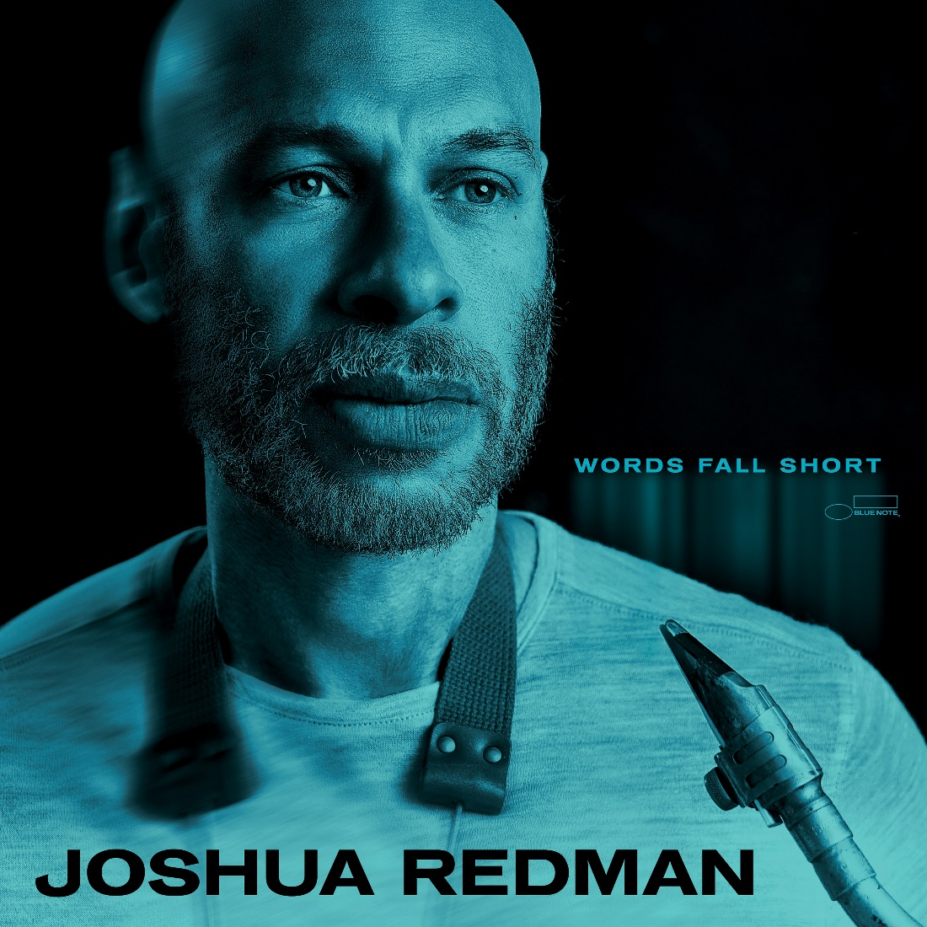

Joshua Redman has announced the June 20 release of his second Blue Note album, Words Fall Short, a collection of original compositions that serves as the introduction of his new quartet featuring pianist Paul Cornish, bassist Philip Norris, and drummer Nazir Ebo, which was formed as a working band for the world tour behind the saxophonist’s 2023 label debut where are we. As the quartet performed steadily on the road, Redman felt a vibe developing and was inspired to bring them into the studio to record a set of music he had composed during the pandemic that embraced the shifting moods of wistfulness, sadness, and resolve, including the stunning opening track “A Message To Unsend.” The album also features special guest appearances by vocalist Gabrielle Cavassa, saxophonist Melissa Aldana, and trumpeter Skylar Tang.

Redman acknowledges that the album title could be viewed ironically—his previous project was his first to feature a vocalist (Cavassa)—yet Words Fall Short is anything but a comment on the saxophonist’s last triumph. More accurately, his latest offering is an organic next step, a collection of previously unheard originals brought to life by inspiring new collaborators. “It’s impossible for me to will a project into being,” he says of the wide-ranging adventures he has embarked upon in what is now his fourth decade as a recording artist. “This album came out of a working environment that inspired me to dig into compositions that hadn’t found a home yet.”

In building a new rhythm section, Redman found himself drawn to younger players he had recently encountered. Norris and Ebo came aboard first, and Redman quickly knew he had made the right moves. “Not since Christian McBride can I recall experiencing an acoustic jazz bassist who seemingly has it all together at such a young age,” he says of Norris, “and Nazir has groove in spades, a groove that is super-flexible, in the flow of the moment, and with an innate sense of architecture that always serves the song.” By the summer of 2023, Cornish had completed the quartet’s transformation. “Paul is the perfect balance of empath and contrarian, challenging everyone to break away from established patterns, while still always making the music feel good and natural in the moment.”

Cornish, Norris, and Ebo impress on each of the album’s eight tracks. While they have moments to emerge and take the spotlight, they also provide a distinctive ensemble personality, one in which spontaneity and sensitivity keep the music fluid yet coherent. They are a rhythm section with character, one in sync with the priorities of their leader. “My approach to bandleading is unchanged,” Redman says. “Play with the best musicians I can find, virtuosos who have mastered all the different jazz vocabularies, but who are also great listeners and collaborators — who know how to express their individual brilliance through group improvisation and collective interaction.”

Redman will be celebrating the album release with shows at the Blue Note Jazz Club in New York City from June 20-22, with additional tour dates across the U.S. and Europe this summer. Visit joshuaredman.com for more information.

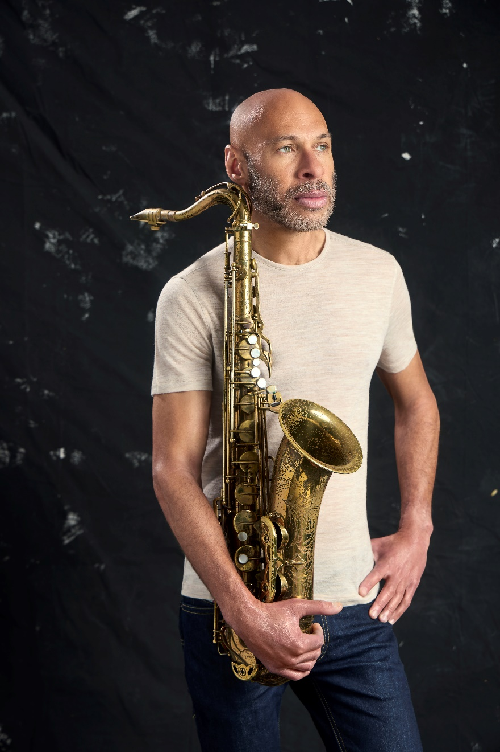
PHOTO BY JEN ROSENSTEIN

Follow Joshua Redman:
Website • Facebook • Twitter • Instagram

Follow Blue Note Records:
Website • Facebook • Instagram • Threads • Bluesky • X • Spotify • Apple Music • YouTube

For more information contact Cem Kurosman at Blue Note Records:
(p) 212.786.8634 (e) cem.kurosman@umusic.com

